Lab Activity 6- Basic Form designed with CSS

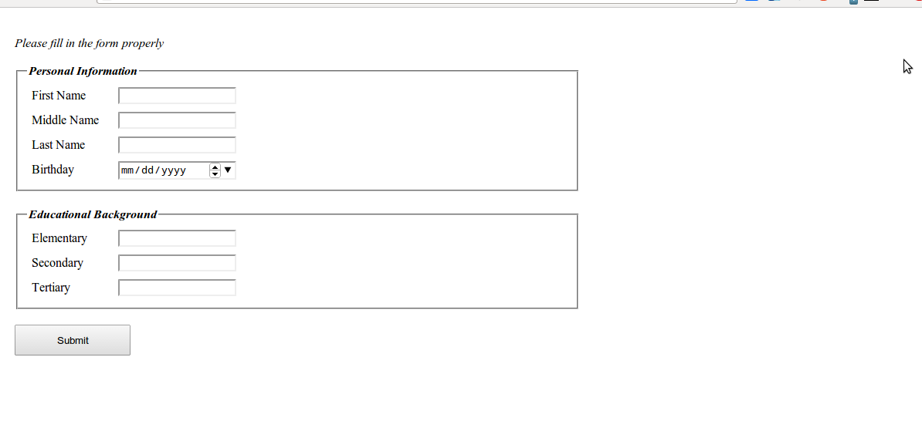
Expected Output

Procedure

- Open notepad++ or any text editor, create a file named labactivity6.html.
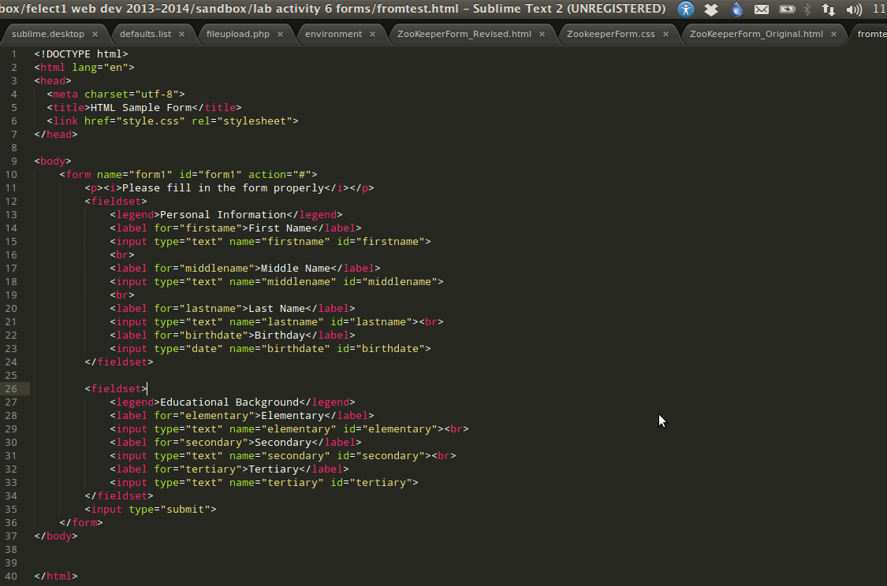
- Write the following code:

- Preview the output in the web browser. You notice that our form don’t look that nice.

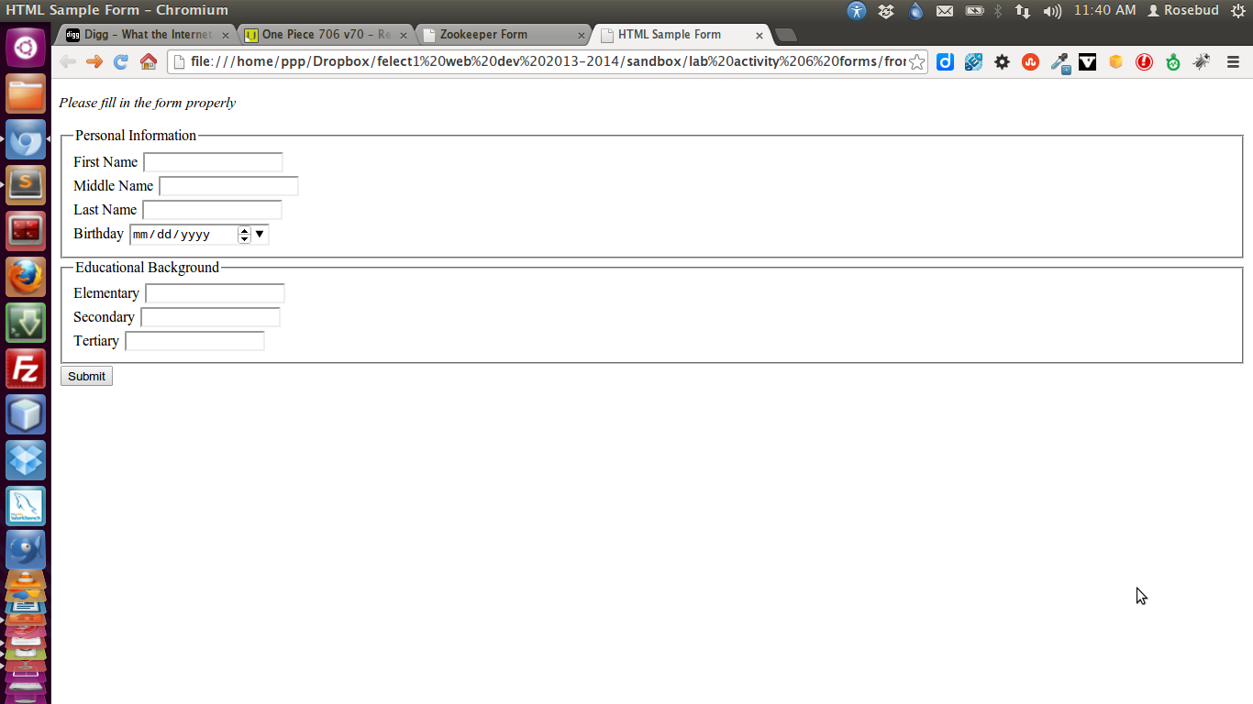

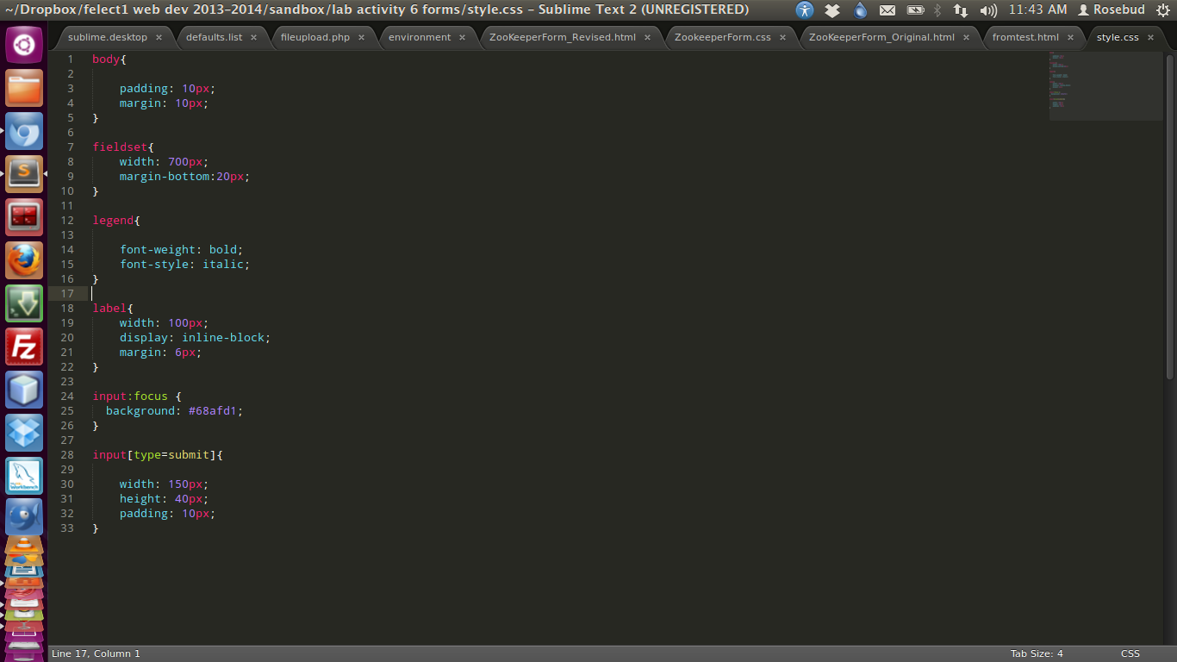
- Now it’s time for us to make our form a little bit elegant by designing it with CSS. Create css file named style.css then write the following css code.

- Then preview again in web browser and notice the changes in our page.

You’ll notice the used of input:focus in the css. It means that you are the designing all the input form elements with a focus attribute. It will apply the style once the element is focused for click by mouse.

Then input[type=submit] means that you are designing the input element with a type of submit.

